SSCO Module-Based Learning

**Installation Instructions**

# Getting the Web Application

The web application can be cloned or downloaded as a zip file from Github.com

## Without Git application

* Go to this link : <https://github.com/kevcal69/ssco_mbl.git>.
* Change the branch to sidebar.

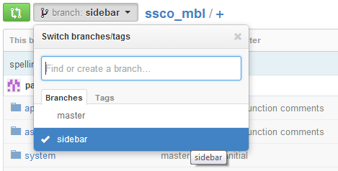

Figure 1: Change branch to sidebar

* Download the web application by clicking “Download ZIP”.

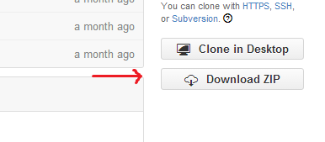

Figure 2: Image can be found at the lower right corner of the web page

* Go to the web server root directory of your web server and extract the downloaded ZIP. *(Look for documentation of your preferred web server about the root directory).*

## With Git (For terminal version only. Refer to Git documentation for using the Git GUI)

* Make sure to set up git first perfectly. Refer to the Git documentation on how to set up.
* Open Git bash, cd to web server document root directory and type the command:

cd C:\web_server\doc_root_dir (not exact command)

git clone [*git@github.com:kevcal69/ssco_mbl.git*](mailto:git@github.com:kevcal69/ssco_mbl.git)

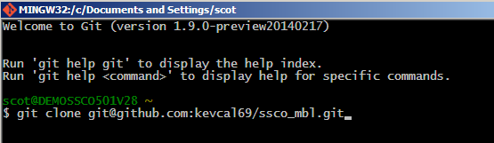

Figure 3: Cloning the web app in git bash

* Now switch the branch to sidebar and do a pull request from the repository

*git checkout sidebar*

*git pull origin sidebar*

# Installing the Web Server

The web application needs a web server for it to run. In this case, the web application needs a web server that supports APACHE, MySQL, and PHP.

It is advisable to use XAMPP because it is cross platform and it is a free web server. But any other web server is also fine. However, be sure to check if the **PHP version is >= 5.0.0** and **5.5.36 => MySQL Community Server (GPL).**

Refer to the installation guide of the web server in its documentation.

(List of recommended web servers below)

* XAMPP (cross platform) *all further examples on will be based on this web server
* LAMPP (Linux)
* WAMP (windows)
* MAMP (Mac and Windows)

# Setting up the Database

Web servers have almost the same and familiar options and contents. Usually, the XAMPP control panel can be accessed through [*http://localhost*](http://localhost) or [*http://127.0.0.1*](http://127.0.0.1)

In the XAMPP Control Panel:

* Go to XAMPP control panel. Settings can be changed according to the user’s preference. Irrelevant functions of the control panel will not be discussed. If they are found to be important, just refer to the web server’s documentation for further details.
* Click phpMyAdmin to go to the phpMyAdmin control panel. The phpMyAdmin is the GUI and makes it easier to manipulate the web application database and MySQL queries.
* Create a database named “ssco_mbl”.
* Click the database and then click the import. The import function will upload an SQL dump of the premade database.
* After going to the import tab click upload file and browse the SQL dump file. The SQL dump file can be found at the root directory of the project folder, inside the web server document root directory, named ssco_mbl.

C:\web_server\doc_root_dir\project_name\ssco_mbl.

* After importing, the tables are created automatically. There is an initial data that is for the admin. This is for logging in to the CMS of the website.

Username: admin

Password: admin

* Don’t forget to change the password after the first time login.

Web Server Running on VM

* Sometimes it is inevitable that web server needs to be on VM in order to run. This might because the host computer does not have administration privileges.
* First, webserver needs to be installed in the VM.
* After the setup, change the setting of the VM’s network adapter to share with the host IP address. This is necessary in order for the web server’s (XAMPP) control panel to be access.
* The control panel can be access by replacing the http://localhost by <http://IP_Adress_of_the_VM> (example <http://192.168.45.51>)

# Connecting the Web App to its Database

The web app is based on the CodeIgniter PHP framework by EllisLab, so the configuration must be organized to control the smooth flow of the server-client processes.

Changing the config.php

* Browse through the folder of the web app

Location : ssco_mbl/application/config

* Find the datasebase.php and config.php files
* The database.php file consists of information about the MySQL database you want to connect to.

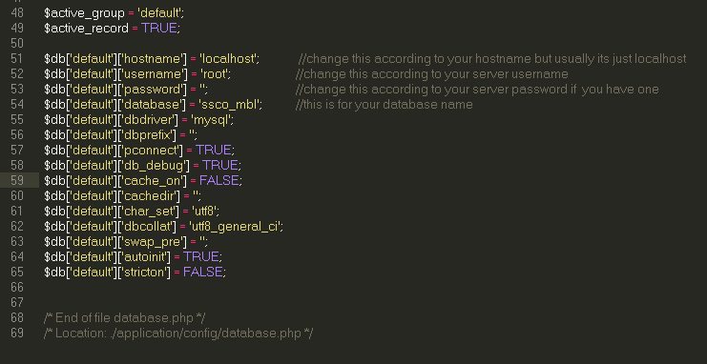

Figure 4 : Database.php snapshot

* config.php contains the main configuration of the web app
* It is necessary to change the base_url to your IP Address



Figure 5 : Config.php base_url snapshot

Now the web application can be accessed through http://some_ip_adress/ssco_mbl